*The following research paper analyzes Work Breakdown Structures based on the optimal level of detail, different types of WBS, and how they are used in the construction industry.*

**Literature Review**

**3**

LR

PJM6005 Project Scope Management

Module 5 – Research Paper

**PREPERATION:**

By: John DiSessa

For: Professor Gray

On: December 11th, 2022

**Abstract**

This research paper analyzes the contents, utility, and applications of Work Breakdown Structures (WBS). A WBS is a project management tool that displays all the necessary components a project must complete in order to be successful. When completed thoroughly, it will identify risks, costs, resources, communication, and all other essential project characteristics, present them in a chart that is easy to understand, and make it streamlined for project members to act upon them in an organized manner. In addition to identifying what components make up a good work breakdown structure and the benefits good work breakdown structures have, this paper focuses on how they are utilized in the construction industry due to their prevalence and success within the industry.

**Introduction**

The following research focused on answering the following three research questions:

* What is the optimal level of detail for a work breakdown structure?
* What are the practical differences between deliverable-based and phased-based work breakdown structures?
* Why are work breakdown structures so useful in the construction industry?

My goal was not to just know why work breakdown structures are important, but to truly understand the optimal scenarios for creating and implementing them. For the casual observer, it is easy to see why they are important because they bring simplicity and organization to complex projects. They can help identify roadblocks in a project that otherwise would have been overlooked. These roadblocks could add significant time and costs to the project that were not planned. However, I believed that creating a work breakdown structure without the true understanding of their capabilities will lead to as much confusion as conducting a project without a work breakdown structure at all. A poorly created work breakdown structure will lead to confusion and mismanagement whereas an optimal work breakdown structure will encourage communication, proper resource allocation, and accurate estimates that can make the project easier to complete.

**Method: WBS Details**

When creating a WBS, it is best to create it as a hierarchal tree structure with three levels. The top levels should be made up of either the project’s most important deliverables or the most critical phases from the project lifecycle.1 As seen in Exhibit A, Level 1 is labeled as I with sublevel A which has its own sublevels 1 and 2.

*Exhibit A1*

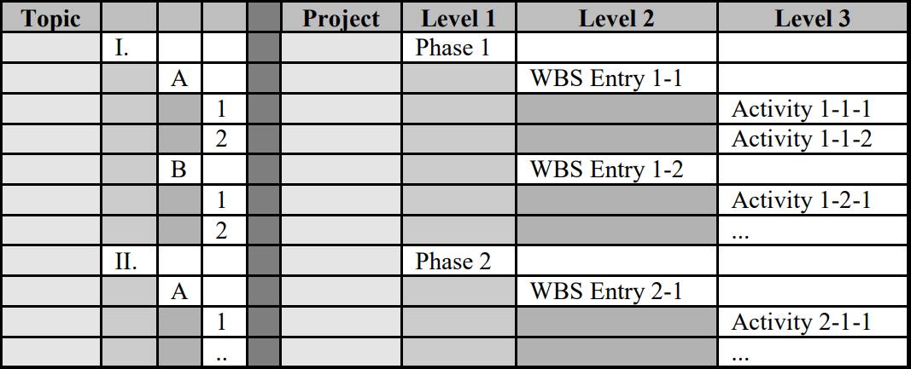

The most important parts of creating the hierarchal structure come down to identifying the top levels concisely and decomposing them into levels two and three with the necessary supporting entries and activities. The entries (Level 2) *must correspond to the deliverables or phases* (Level 1). This level of detail is crucial for developing a good WBS because any entries that are too vague could be interpreted differently by different people. Entries that are too specific can add unnecessary work or entries that are too in-depth would be out of place considering this is supposed to summarize the steps the project needs to take. Granular details are best left for Level 3 activities or described in a corresponding WBS Dictionary. It is important to remember that the WBS is supposed to be a concise summary that is easily readable. To best create an entry with the perfect level of detail, one must follow the following rule: “All WBS Entries that directly correspond to deliverables should be named as noun deliverables or adjective/noun deliverables. Examples include ‘Specification’ or ‘Design Specification’.” This naming convention is very important for differentiating between the levels because Level 3 activities are verbs, since they compose all of the ‘activities’ one must do to complete the entries (Level 2). The Level 2 entries are nouns/adjectives because they summarize the list of completed tasks that each deliverable or phase (Level 1) must have in order to be marked as complete. Level 3 activities should be specific verbs and not general verbs like ‘perform’ or ‘complete’ since these verbs do not communicate anything new.

In order to avoid competing activities, “each component must be logically distinct, as everyone who sees the WBS needs to understand what the deliverable or outcome will be from each WBS Entry. What logically distinct means is that the breakdown of a higher level deliverable to its lower level components must make sense. Each of the lower level components musts be distinguishable as unique, and they must be recognizable as part of the higher level deliverable.”1

The next step in WBS creation is making sure that each activity is unique and clearly assigned to each entry. As a general rule of thumb, “each activity should be assigned to a single individual, and that individual should be able to complete it in 1 to 10 working days.”1 After all three levels are completed, the project manager must validate the WBS to make sure it is completed with an appropriate level of detail. One strategy is to use a bottom-up approach. “A bottom-up validation works like this: - For each WBS Entry that decomposes into Activities, ask yourself the question: ‘If I had all the deliverables from each of these Activities, would my WBS Entry deliverable be complete?’ If the answer is yes, move on to the next WBS Entry. If the answer is no, add in the missing Activities.”2 Despite the tedious work in creating a detailed WBS, it is not meant to be followed 100% of the time during the project. Complex projects often have unplanned budget changes, staff changes, or other unforeseen constraints. Because situations change, the WBS should be simple enough where the project manager can go back to view the WBS and make small changes according to the changes in resources.

As seen in Exhibit B, this phase-based WBS has the correct numbering sequence (1, 1.1, 1.1.1) that clearly identifies the three levels. All of the phases, entries, and activities are appropriately named which clarify how everything can be completed. Notice, however, that there is not an excess amount of detail. If the project is complex, some project managers may create a Work Breakdown Structure Dictionary. This can be thought of as a supplement to the Work Breakdown Structure and is the appropriate document to write a few sentences explaining each phase, deliverable, entry, or activity that can be referenced when team members need more details. Since WBS Dictionaries are beyond the scope of this research paper, one can read a template created by the CDC if they are interested in learning more.3

*Exhibit B1*

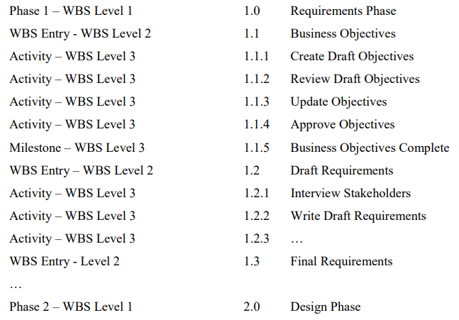

**Method: Deliverable-based vs. Phased-based WBS**

While both types of Work Breakdown Structures can achieve desired results, they are inherently different and are applicable in different settings. “The WBS can be structured in either of two ways. The first approach structures the WBS primarily from a deliverables perspective, in that the highest level (Level 1) represents the major deliverables that the project is committed to create. The second approach is from a life cycle perspective, in that the highest level entries in the WBS correspond to the major phases of the life cycle.”1 We will first analyze a deliverable-based WBS, as seen in Exhibit C.

*Exhibit C4*

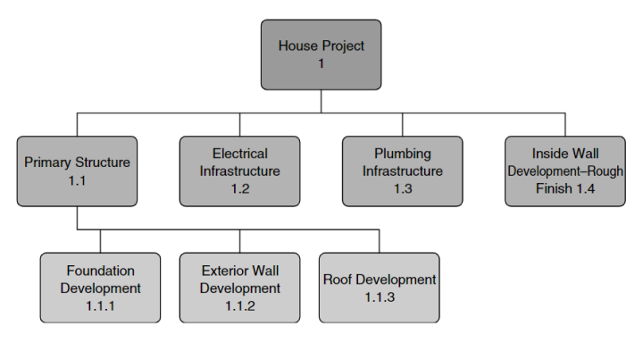

If we assume the project in Exhibit C is a large construction project for building a home, there could be several major deliverables, such as the house, driveway, a shed, etc. Exhibit C focused on just the house. To complete the house, four entries are listed here in Level 2. Breaking down just the primary structure, notice how there is more than 1 activity. For a deliverable-based WBS, if you cannot breakdown a Level 2 entry into more than 1 activity, you need to reevaluate your Level 2 entry. The Level 3 activities can follow the SMART goal methodology of being specific, measurable, attainable, realistic, and timely. Even though we do not have to explain all five elements in each activity, an activity is only worth adding to the WBS if it can be easily quantified and achieved. If this were a phased-based WBS, the Level 2 entries would be more time-based. For deliverables, they can be worked on *concurrently* by multiple project members. For a phased-based WBS, each phase must be completed in a *sequential order* like stacking building blocks on top of one another. Referring back to Exhibit B, the three entries in order are Business Objectives, Draft Requirements, and Final Requirements. Logically it makes sense to complete these in order because you need to know the goals of the project first in order to shape the project direction. Once that is complete, you can list of specific requirements that the project has. After that, you can finalize the requirements. Completing these out-of-order would be completely ineffective, which is why it is critical to select the most applicable type of WBS. Using the example of a home construction, they used the correct type of WBS. Even though a phased-based WBS could work for home construction, it would be an inefficient way to run the project since there are aspects on the property that can be worked on concurrently and independently.

What they both have in common, however, is all Level 3 activities, when completed, must entirely complete the deliverable or phase. Even small activities that are necessary for completion must be included in the WBS in order to ensure every part of the project is completed. The risks and costs associated with missing project activities grow exponentially since the risk of re-work and safety increase as items are missed. It is critical everything be planned out and specified in the WBS. Even though the sequence of tasks and the resource allocations vary between WBS types, both strategies are effective when used in the right setting.

**Discussion: Construction Industry**

During my research for this paper, I noticed how almost all of the examples were related to construction projects. This left me wondering why Work Breakdown Structures are so prevalent in the construction industry as opposed to other industries. I identified four major reasons that explain why Work Breakdown Structures are so useful for construction projects.

First, construction projects are typically very *complex*. There are civil engineering, environmental engineering, logistical, and political considerations all typically involved in varying degrees depending on the project. Each of these sectors has their own complications so it is critical that the Work Breakdown Structure is used in order to determine all necessary considerations in advance. The construction industry is also unique in that almost all other industries rely upon the construction industry to build their facilities. Other industries are experts in their own matters but have to outsource the building of their facilities to the construction industry. This adds another layer of complexity in that each industry a construction project works for has their own wants and needs. A WBS is necessary in order to keep track of different requirements from project to project.

Second, construction projects all have *different sources and levels of funding*.5 This directly impacts the amount of resources the project has as well as the resource allocation. Having a proper WBS is critical in order to track costs and plan to utilize the optimal level of staffing. Additionally, each project will have different rules for tracking expenses. Some publicly funded projects will require strict accounting since they utilize taxpayer funds. Large corporations will require strict accounting in order to report to shareholders. Those projects are typically larger which can increase the likelihood that some money is used sub-optimally. A good WBS will keep the project operating efficiently.

Third, construction projects almost always have huge *safety and liability concerns*. “Construction has now become an industry with the highest risk of work accidents. The risk of workplace accidents in construction can be caused by several factors, such as the work method, workplace, environment, human factors and poor safety management system.”6 By using the WBS and breaking down each aspect of the project, the project manager would be more likely to make small changes to project safety at the critical steps. They can better prepare for risky steps by asking for additional funding, extra resources, or plan to delay that step until the safety increases. Unplanned project components could put project managers in situations where they either force an unplanned delay or continue on despite the risky conditions in order to meet deadlines. If an accident did occur, the costs in terms of time and money would be significantly higher than if the project manager took the time to plan out each aspect of the project in the WBS and make the proper safety considerations in advance.

Lastly, what often gets overlooked is that construction projects are more *tangible* than almost any other project. Completing each deliverable or phase can be easily verified by actually seeing a building construction taking place, for example. There is manual labor that takes place that is quantified by worker timesheets. An IT project, for example, is not as tangible because many components are virtual. There is not the level of visual and timely feedback when creating or completing parts of the WBS like there is with construction projects. Many construction project components have to be signed-off by certain staff members which is easy to track with a WBS, whereas IT project components are done individually with minimal supervision. Each individual may not have the knowledge or self-discipline to monitor their work breakdown structures so the benefits of the WBS are diminished as individuals don’t follow the WBS. A Work Breakdown Structure has increasingly positive effects as more project stakeholders follow it, which is much easier to accomplish with the tangibility of construction projects.

**Conclusion**

Work Breakdown Structures are some of the most effective project management tools due to their simplicity and efficacy. Even though they can delay a project start, the time used to create them before starting a project is a worthwhile tradeoff. When creating a WBS, one should clearly differentiate between deliverables, phases, entries, and activities, follow the respective numbering rules, and use the proper grammar for naming each step. The WBS should provide an easy visual for people to reference and follow during the course of the project. Selecting the correct type of WBS is critical as well depending on if project components can be completed concurrently or if they have to be completed sequentially. The construction industry is the best example to demonstrate creating and using excellent work breakdown structures because the industry characteristics are the exact characteristics that work breakdown structures quantify. The industry is complex, has varying funding levels and sources, has safety concerns, and the project results are tangible. This research paper has demonstrated both the benefits of work breakdown structures, explained how to optimally create a work breakdown structure, and provided real-world examples in an attempt to increase their usage in all project management scenarios.

**References**

1 Colenso, Kim. “Creating The Work Breakdown Structure.” *Work Breakdown Structure - An Introduction*, Artemis Management Systems, 2000, http://www.exclusive-pm.ru/files/625/wbs.pdf.

2 Burghate, Mukul. *Work Breakdown Structure: Simplifying Project Management*. International Journal of Commerce and Management Studies, June 2018, https://www.ijcams.com/wp-content/uploads/2018/11/WBS-2.pdf.

*3 WBS Dictionary Template*. Centers for Disease Control and Prevention, https://www2a.cdc.gov/cdcup/library/templates/CDC_UP_WBS_Dictionary_Template.doc.

4 Zuidema, Dennis. *Work Breakdown Structure as a Method for...* University of Twente, Jan. 2022, https://essay.utwente.nl/89649/1/Zuidema_BA_BMS.pdf.

5 Polonski, M. *Application of the Work Breakdown Structure in Determining Cost Buffers...* Faculty of Civil Engineering, Warsaw University of Technology, Oct. 2015, https://www.journals.pan.pl/Content/84004/mainfile.pdf.

6 Tamara, Ayasha, et al. *The Development of Safety Plan to Improve OHS Performance for Construction...* IOP Publishing Ltd, Nov. 2019, https://iopscience.iop.org/article/10.1088/1755-1315/426/1/012016/meta.